
E-COMMERCE Site PROPOSAL
Harvest Natural Foods Ltd.

November 6, 2025
feng li
Winnipeg, Manitoba

CONTENTS
Executive Summary 2
Description of the E-commerce Site 2
Business Overview 2
Business Description 2
Database Structure Description 3
Database Tables 3
Entity Relationship Diagram 7

Executive Summary
This proposal outlines a comprehensive plan to develop a fully-featured Ruby on Rails e-commerce platform for Harvest Natural Foods Ltd. The proposed solution will provide a robust online storefront with complete product management, secure checkout processing, and comprehensive order tracking capabilities.

Description of the E-commerce Site

Business Overview
Harvest Natural Foods Ltd.

Business Description
Harvest Natural Foods is a well-established Winnipeg-based retailer of organic and natural foods, serving the Manitoba community for 15 years. The company currently operates two brick-and-mortar locations in Winnipeg with a team of 23 employees, including store managers, nutritionists, and customer service representatives.
- Current Operations:
Harvest currently sells its products exclusively through its physical retail locations. They offer a diverse range of organic produce, natural supplements, eco-friendly household products, and specialty dietary items. While they have built a loyal customer base through their in-store experience, they recognize the growing need to expand into the online marketplace to remain competitive and serve customers who prefer the convenience of home delivery.
- Products for Online Sale:
The online store will feature its complete product catalogue, including:
- Organic fresh produce and frozen foods
- Natural vitamins and supplements
- Gluten-free and allergen-friendly products
- Eco-friendly household and personal care items
- Specialty teas, coffees, and health beverages
- Organic snacks and packaged goods
- Target Demographic:
The primary target demographic for this online store includes:
- Age Range: 25-55 years old
- Location: Primarily Winnipeg and surrounding Manitoba communities, with potential expansion to other Canadian provinces
- Lifestyle: Health-conscious individuals and families who prioritize organic, sustainable, and ethically-sourced products
- Income Level: Middle to upper-middle class households with disposable income for premium natural products
- Shopping Behavior: Busy professionals and parents who value the convenience of online shopping and home delivery
- Values: Environmental sustainability, health and wellness, and supporting local businesses

Database Structure Description
The proposed database structure is designed to handle complex e-commerce operations while maintaining data integrity and supporting future scalability. The schema accounts for product management, customer orders with multiple items, quantity tracking, historical price preservation, and tax calculation.

Database Tables
- users
Store customer account information and authentication credentials.
Column Name | Data Type | Notes
id | integer | Primary key
email | string | Unique, required
encrypted_password | string | Hashed password
username | string | Unique identifier
created_at | datetime
updated_at | datetime
- provinces
Store Canadian provinces and territories with their respective tax rates.
Column Name | Data Type | Notes
id | integer | Primary key
name | string | Province/territory name
code | string | Two-letter code (e.g., MB)
gst_rate | decimal(5,2) | GST percentage
pst_rate | decimal(5,2) | PST percentage
hst_rate | decimal(5,2) | HST percentage
created_at | datetime
updated_at | datetime
- addresses
Store customer shipping and billing addresses.
Column Name | Data Type | Notes
id | integer | Primary key
user_id | integer | Foreign key to users
province_id | integer | Foreign key to provinces
street_address | string
city | string
postal_code | string
address_type | string | 'shipping' or 'billing'
created_at | datetime
updated_at | datetime
- categories
Organize products into logical groupings for navigation and filtering.
Column Name | Data Type | Notes
id | integer | Primary key
name | string | Category name
description | text | Category description
created_at | datetime
updated_at | datetime
- products
Store product information and current pricing.

Column Name | Data Type | Notes
id | integer | Primary key
name | string | Product name
description | text | Product details
price | decimal(10,2) | Current price
stock_quantity | integer | Inventory count
on_sale | boolean | Sale status flag
is_new | boolean | New product flag
created_at | datetime
updated_at | datetime
- product_categories
Join table to support many-to-many relationship between products and categories (allows products to belong to multiple categories).
Column Name | Data Type | Notes
id | integer | Primary key
product_id | integer | Foreign key to products
category_id | integer | Foreign key to categories
created_at | datetime
updated_at | datetime
- orders
Store customer order headers with totals and status information.
Column Name | Data Type | Notes
id | integer | Primary key
user_id | integer | Foreign key to users
address_id | integer | Foreign key to addresses
status | string | 'pending', 'paid', 'shipped'
subtotal | decimal(10,2) | Pre-tax total
gst_amount | decimal(10,2) | GST charged
pst_amount | decimal(10,2) | PST charged
hst_amount | decimal(10,2) | HST charged
grand_total | decimal(10,2) | Final total with taxes
stripe_payment_id | string | Payment processor reference
created_at | datetime | Order date
updated_at | datetime
- order_items
Store individual products within each order with historical pricing.
Column Name | Data Type | Notes
id | integer | Primary key
order_id | integer | Foreign key to orders
product_id | integer | Foreign key to products
quantity | integer | Number of units ordered
price_at_purchase | decimal(10,2) | Product price when ordered
subtotal | decimal(10,2) | quantity × price_at_purchase
created_at | datetime
updated_at | datetime
- payments
Store payment history.
Column Name | Data Type | Notes
id | integer | Primary key
card_type | string | ‘credit’ or ‘debit’
pay_amount | decimal(10,2)
created_at | datetime
updated_at | datetime
- admin_users
Store administrator credentials should be separate from customer accounts.
Column Name | Data Type | Notes
id | integer | Primary key
email | string | Unique, required
encrypted_password | string | Hashed password
created_at | datetime
updated_at | datetime

Entity Relationship Diagram
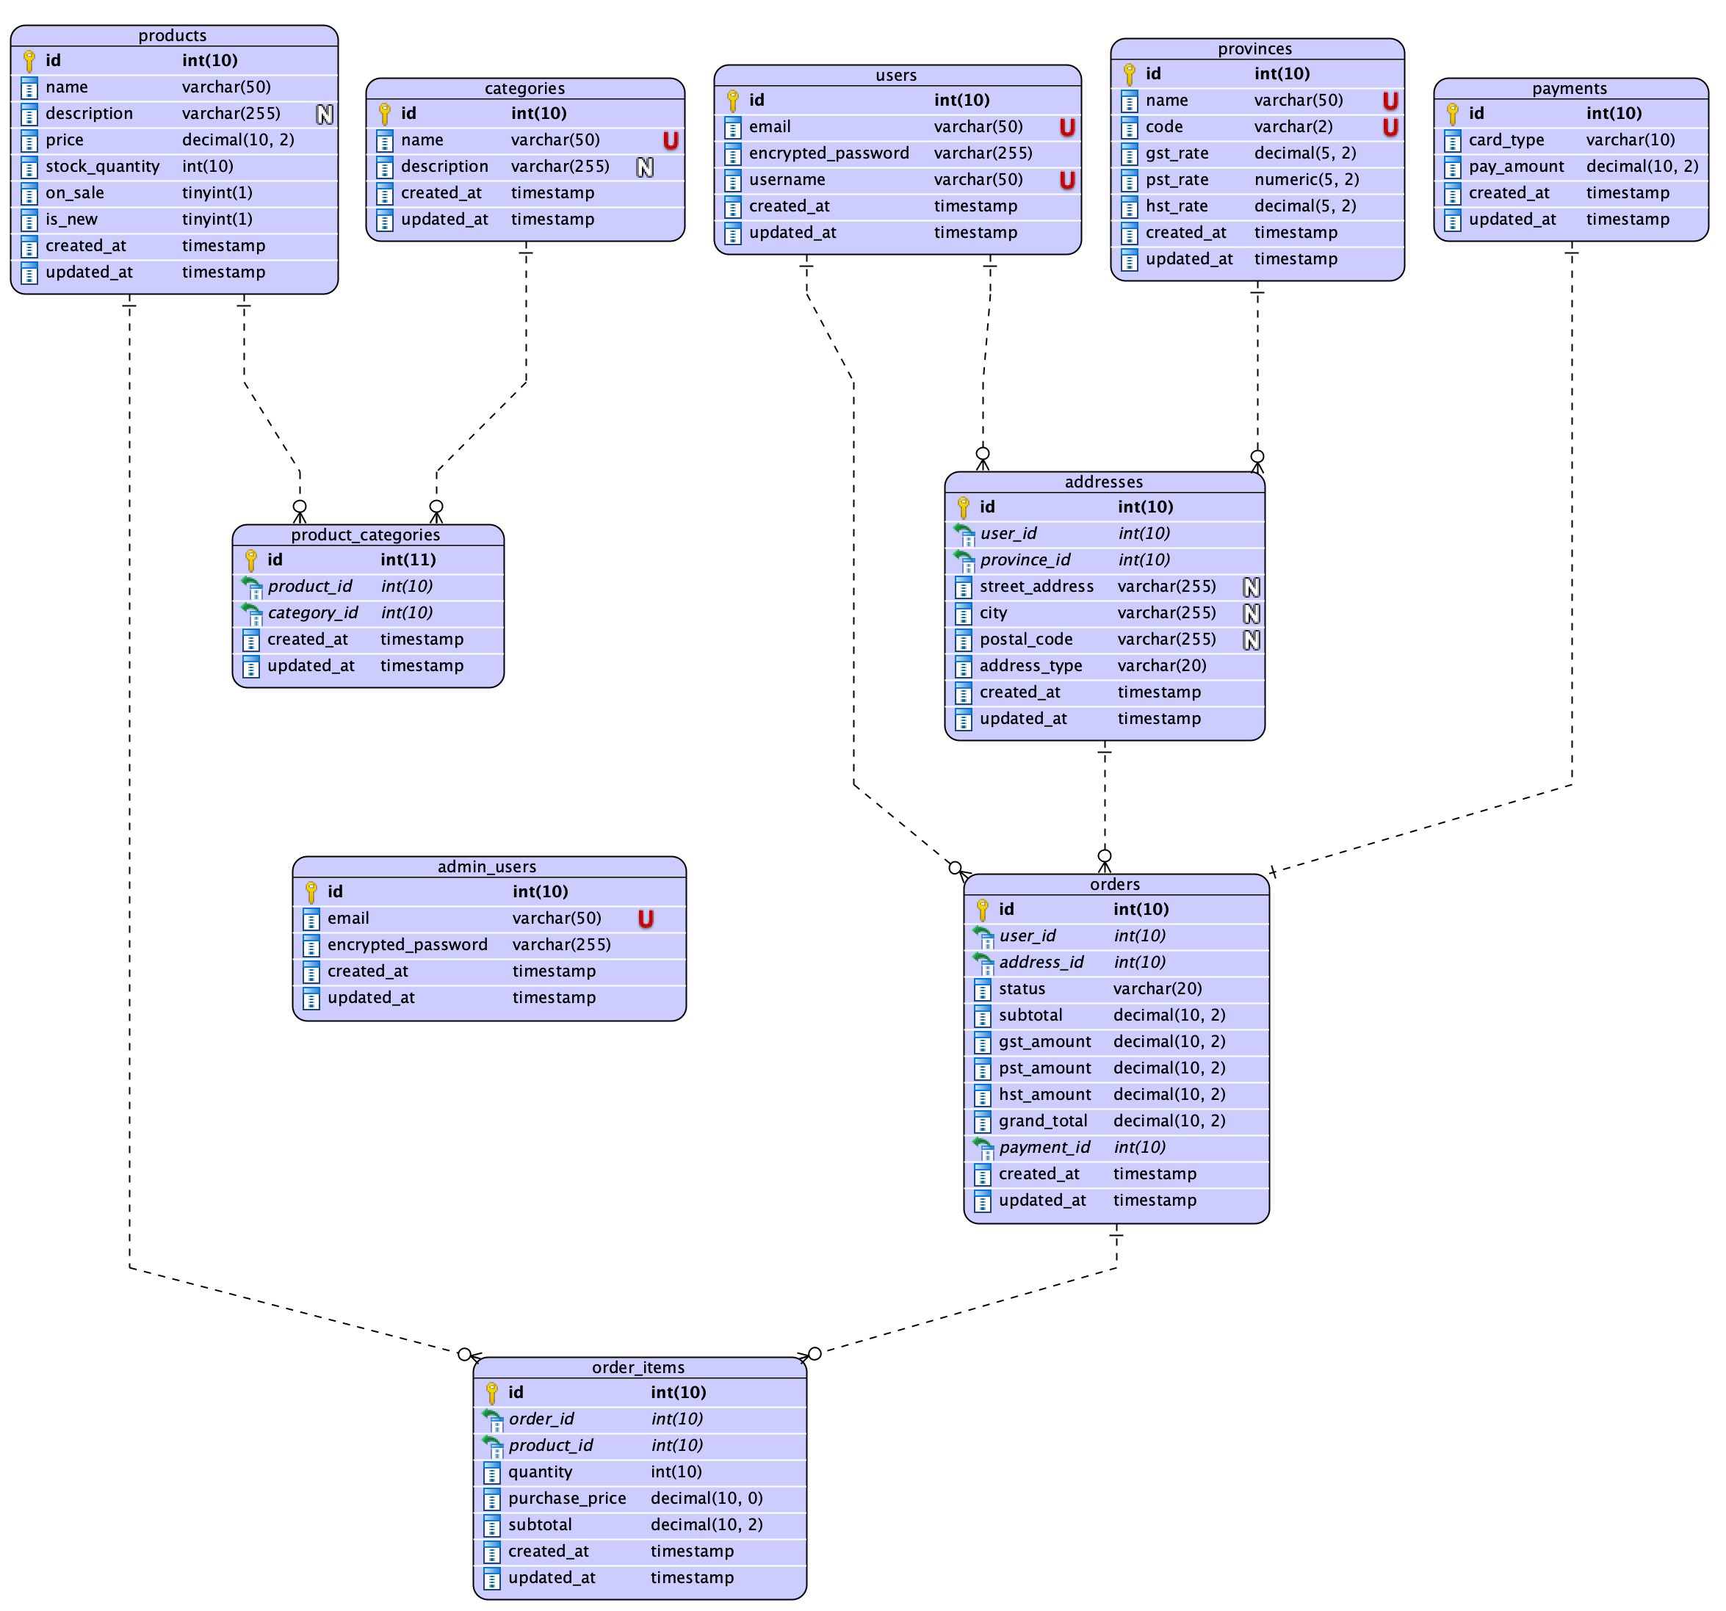
One-to-Many Relationships:
- users → addresses: A user can have multiple addresses (one for shipping, one for billing)
- users → orders: A user can place multiple orders over time
- provinces → addresses: A province is referenced by many addresses
- orders → order_items: An order contains multiple line items
- products → order_items: A product can appear in many order items
Many-to-Many Relationships:
- products ↔ categories: Implemented via join table product_categories (allows products to belong to multiple categories)

